**MODULE: 1**

**SE – Overview of IT Industry**

1. What is software? What is software engineering?

**What is software?**

* Software is the language of computer.
* Software is a set of instructions, data or programs used to operate computers and execute specific tasks.

**What is Software Engineering?**

* Software engineering is the art of developing quality software on time and within budget.
* Software engineering is a systematic approach to the design, development, operation, and maintenance of a software system.

2. Explain Types of software.

* **3** main groups depending on their use and application.
* **1) System Software / Operating System**
* **2) Application Software**
* **3) Programming Language**
* **1) System Software :**
* System software is a type of computer program that is designed to run a computer is hardware and application programs.
* Basically OS coordinates the different hardware components of a computer.
* System software manages the computer’s basic functions, including the many more operating systems.
* Ex. Linux, Window, Android, iOS
* **2) Application Software :**
* Is the general designation of computer programs for performing user tasks.
* Types of Application Software :
* **1) Mobile Application**
* **2) Desktop Application**
* **3) Web Application**
* **1) Mobile Application :**
* Application that run on mobile.
* A mobile application is a software application developed specifically for use on small, wireless computing devices, such as Smartphone’s and tablets, rather than desktop or laptop computer.
* Ex. Instagram, Facebook, etc
* **2) Desktop Application :**
* Desktop application is a dedicated software program designed to run on a standalone computer, enabling end-users to execute specific tasks.
* That runs stand-alone in a desktop or laptop computer.
* Anti-Virus is an application and so is the media player.
* Ex. Outlook for email, Firefox, Google Chrome, etc
* **3) Web Application :**
* Web application is a software that runs in your web browser.
* They allow you to access complex functionality without installing or configuring software.
* Web application users an active network connection.
* Ex. Google.com, Facebook.com, etc
* **3) Programming Software :**
* Programming software is software which helps the programmer in developing other software.
* This software is pa written in a programming language.
* The purpose of programming is to create a program that exhibits a certain desired behavior.
* Ex. C++, Java, Python, etc

3. What is SDLC? Explain each phase of SDLC.

**What is SDLC?**

* SDLC (Software Development Life Cycle).
* SDLC is the cost-effective and time-efficient process that development teams use to design and build high-quality software.
* SDLC is a structure imposed on the development of a software product that defines the process for planning, implementation, testing, documentation, deployment, and ongoing maintenance and support.
* There are a number of different development models.
* A Software Development Life Cycle is essentially a series of steps, or phases, that provide a model for the development and lifecycle management of an application or piece of software.
* The methodology within the SDLC process can vary across industries and organizations, but standards such as ISO/IEC 12207 represent processes that establish a lifecycle for software, and provide a mode for the development, acquisition, and configuration of software systems.
* SDLC Phase:
* **1) Requirement Collection / Gathering**
* **2) Analysis**
* **3) Design**
* **4)Implementation**
* **5)Testing**
* **6)Maintenance**
* **1) Requirement Collection / Gathering :**
* When the project team begins to understand what the customer wants from the project.
* During the requirements gathering sessions, the project team meets with the customer to online each requirement in detail.
* **2) Analysis :**
* Gathering all the specific details required for a new system as well as determining the first ideas for prototype.
* The analysis phase defines the requirements of the systems, independent of how these requirements will be accomplished.
* **3)Design :**
* The design phase of the SDLC is a critical step in developing the conceptual blueprint of a software project.
* This phase involves transforming the software requirements gathered during the requirements analysis phase into a structured design document.
* **4)Implementation :**
* Implementation phase is initiated after the system has been tested and accepted by the user.
* In this phase, the system is installed to support the intended business functions.
* System performance is compared to performance objectives established during the planning phase.
* **5)Testing :**
* Once the developers build the software, then it is deployed in the testing environment.
* Then the testing team tests the functionality of the entire system.
* Quality is a distinguishing attribute of a system indicating the degree of excellence.
* **6)Maintenance :**
* Maintenance is where the software is monitored to ensure it continues to function as it was designed to, and repairs or upgrades are performed as needed.
* The developing organization or team will have some mechanism to document and track defects and deficiencies.
* After the software is released into production, updates or upgrades will need to be made.

4. What is DFD? Explain Create a DFD Diagram on Flipkart.

**What is DFD?**

* DFD (Data Flow Diagram).
* DFD is a maps out the flow of information for any process or system.
* DFD is the abbreviation for data flow diagram.
* DFD is a traditional visual representation of the information flows within a system.
* A neat and clear DFD can depict a good amount of the system requirements graphically.

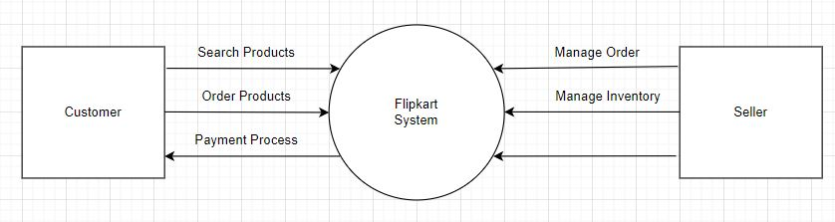­­­

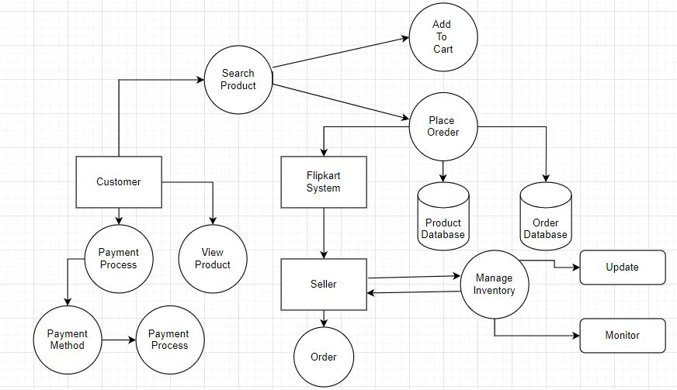

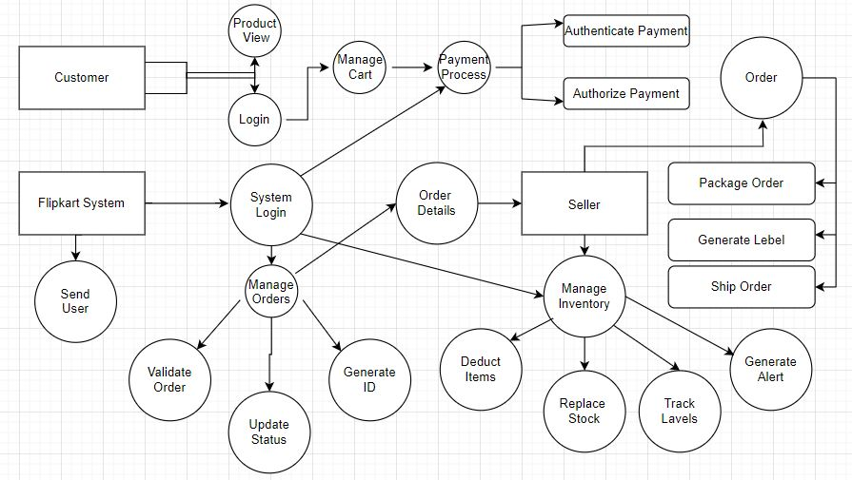

5. What is Flow Chart? Create a flowchart to make addition of two numbers.

**What is Flow Chart?**

* A flow chart is a graphical or symbolic representation of a process. Each step in the process is represented by a different symbol and contains a short description of the process step.
* The flow chart symbols are linked together with arrows showing the process flow direction.
* A flowchart is a diagram that depicts a process, system or computer algorithm.
* They are widely used in multiple fields to document, study, plan, improve and communicate often complex processes in clear, easy-to-understand diagrams.

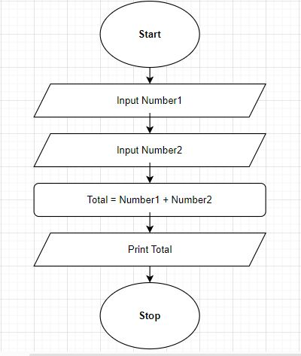

6. What is Use Case Diagram? Create a use-case on bill payment on paytm.

**What is Use Case Diagram?**

* A use case diagram is the primary form of system/software requirements for a new software program underdeveloped.
* UML (Unified Modeling Language).
* A UML use case diagram is vital tool in system design, it provides a visual representation of how users interact with a system.
* A use case diagram is a graphical depiction of a user's possible interactions with a system.
* The use cases are represented by either circles or ellipses.
* It serves as a blueprint for understanding the functional requirements of a system from a user is perspective, aiding in the communication between stakeholders guiding the development process.
* A use case diagram shows various use cases and different types of users the system has and will often be accompanied by other types of diagrams as well.
* 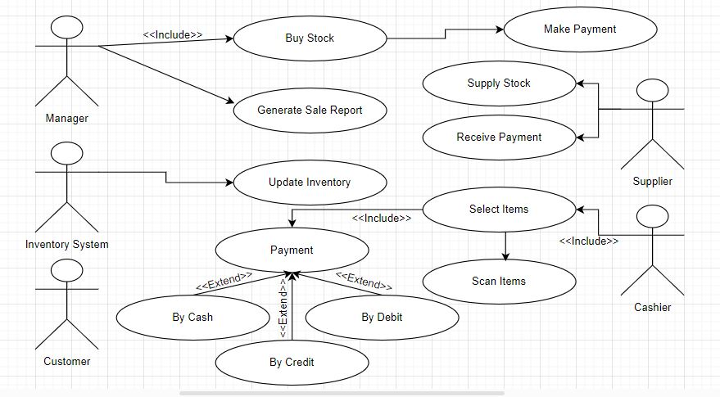The actors are often shown as stick figures.